___________________________________________________________________________


RESEARCH AND CONCEPT DOCUMENT (RCD)

CERTIFICATE VERIFICATION SYSTEM (CERTIFY)

DOCUMENT CONTROL

Project Title: Development of DOST Caraga Certificate Verification
System

Document Type: Research and Concept Document (RCD)

Version: 1.0

Prepared by: MIS Unit DOST Caraga

Approved by: ENGR. NOEL M. AJOC
Regional Director

Date: April 2026

EXECUTIVE SUMMARY
This Research and Concept Document presents the proposed Certificate Verification System (CERTIFY) for DOST Caraga. The concept is intended to address recurring issues in certificate issuance, approval, storage, distribution, and authenticity verification by defining a structured information system that may serve as the basis for development, implementation planning, and management approval.
At present, certificate processing is largely dependent on manual consolidation of participant data, spreadsheet-based preparation, separate certificate templates, informal approval routing, and file-based storage. These practices create risks in data accuracy, duplicate records, delayed processing, weak auditability, and difficulty in confirming whether a certificate is authentic.
The proposed CERTIFY system is envisioned as a centralized, secure, and workflow-controlled platform that will manage the certificate lifecycle from participant data collection up to public verification. Under the proposed concept, certificate records will be supported by validated database metadata, controlled approval actions, generated PDF outputs, and QR or token-based verification links.
The system concept aims to provide the following intended capabilities:
- Structured collection and management of participant and recipient data.
- Role-based certificate endorsement, review, approval, and rejection workflows.
- Controlled certificate generation using approved metadata and templates.
- Centralized storage of certificate records and related supporting files.
- Public verification through secure, non-sequential tokens and QR codes.
- Reporting and analytics based on structured certificate and participant data.
This concept supports DOST Caraga digital transformation objectives by proposing stronger governance, improved operational efficiency, better data integrity, enhanced audit readiness, and increased public trust in issued certificates. The document therefore serves as the research and conceptual basis for determining the system scope, technology direction, data flow, security controls, and implementation approach before full development and deployment.

PROBLEM DEFINITION

DOST Caraga currently faces systemic inefficiencies in certificate processing due to the absence of an integrated platform. Certificates are treated as static outputs rather than traceable digital records.

Key Issues:

- Fragmented Processes
  - Participant data, certificate templates, approvals, and outputs exist in separate tools (Excel, email, PDFs).

- Manual and Error-Prone Workflow
  - Repetitive encoding leads to:
    - Typographical errors
    - Duplicate records
    - Inconsistent formatting
- Lack of Verification Mechanism
  - No real-time validation for authenticity
  - Manual verification via email or phone

- Weak Audit Trail
  - No centralized record of:
    - Who generated certificates
    - Who approved them
    - When they were issued

- Limited Reporting Capability
  - No structured data for:
    - Program impact
    - Beneficiary profiling
    - Inclusion metrics

ROOT CAUSE ANALYSIS
The problem stems from four systemic gaps:

Data Fragmentation
Different stages of the process use disconnected tools:
- Input → spreadsheets (xls.), document file (docx.)
- Processing → manual editing
- Approval → manual signing
- Output → PDFs
➡ No single source of truth

Lack of System-Enforced Governance

Manual processes rely on compliance rather than enforcement. No strict control over:

- Signatory authority
- Approval hierarchy

Mismatch of Data Types

- Unstructured Data → participant details
- Unstructured Data → certificate PDFs

➡ No system integrates both efficiently

Absence of Lifecycle Traceability

No complete tracking of:
- Submission
- Validation
- Approval
- Generation
- Distribution

➡ Weak accountability and audit readiness

OBJECTIVES AND DESIRED OUTCOME

OBJECTIVES:

- General Objectives:

Generally, the proposed Certificate Verification System (CERTIFY) aims to establish an integrated information system that will support the digital transformation of certificate issuance and verification processes within DOST Caraga. The system is envisioned to serve as a secure and centralized platform that manages the complete certificate lifecycle, from participant registration and certificate generation to approval, issuance, storage, and public verification.

- Specific Objectives:

The proposed Certificate Verification System (CERTIFY) specifically aims to:

- Centralize certificate management by establishing a unified platform for participant data, certificate generation, issuance, storage, and verification.
- Automate certificate processing to reduce manual intervention, improve turnaround time, and minimize errors in certificate generation and distribution.
- Implement role-based approval workflows to ensure controlled authorization, accountability, and compliance with institutional approval processes.
- Provide secure digital certificate verification through QR code and token-based authentication mechanisms for real-time public validation.
- Strengthen data management and reporting by capturing structured certificate-related data to support monitoring, analytics, and decision-making.
- Improve service efficiency and stakeholder trust through standardized processes, reliable outputs, and accessible verification services.

DESIRED OUTCOMES:

Expected Outcomes

The implementation of the system is expected to result in a streamlined and standardized certificate issuance process, improved operational efficiency, enhanced governance and traceability, secure public verification of certificates, and availability of structured data to support reporting and institutional decision-making.

Key Success Indicators

The success of the proposed system shall be measured using the following performance indicators:

Indicator | Baseline | Target | Means of Verification
Certificate generation turnaround time | Manual, multi-day processing | 80% reduction in processing time | System processing logs
Certificate generation error rate | Frequent manual errors | Less than 2% error incidence | Quality assurance review
Bulk certificate processing capability | Limited manual handling | Certificates generated per batch | System transaction reports
Certificates issued through approved digital workflow | No standardized workflow | 100% of certificates processed through system workflow | Audit trail logs
Transactions with complete audit trail | Minimal documentation | 100% traceable transactions | System audit reports
Approval compliance rate | Manual and inconsistent | 100% approval routing compliance | Workflow records
Certificates with QR/token verification enabled |  | 100% of issued certificates | Verification database
Table 1.1 Key Success Indicator

EXISTING WORKFLOW

The existing certificate issuance process in DOST Caraga is predominantly manual and distributed across multiple disconnected tools and approval channels. The process begins when activity participants submit their attendance information through manual registration forms or spreadsheet-based attendance sheets prepared by the activity organizers. Participant details are then manually encoded and consolidated, usually through spreadsheet applications, serving as the source data for certificate preparation.

Following data consolidation, certificate templates are manually edited one participant at a time or through semi-manual mail merge processes. This stage often requires repetitive formatting, manual insertion of participant names, activity titles, dates, and signatories, increasing the likelihood of typographical errors, inconsistencies, and duplicate records.

Once draft certificates are prepared, they are routed through informal approval channels, often through email exchanges, printed routing, or verbal confirmation from approving authorities. Since approvals are not managed through a controlled system, there is limited traceability and no structured audit trail of who reviewed or authorized the certificates.

After approval, certificates are manually distributed or generated as PDF files and manually distributed to participants through email or other digital channels. Generated certificates are usually stored in separate folders or individual devices without a centralized repository for retrieval or record management.
When certificate authenticity needs to be validated, verification requests are typically handled manually through direct coordination with organizers or issuing offices, requiring additional administrative effort and often causing delays.

This workflow is characterized by fragmented processing, repetitive manual intervention, weak control points, and the absence of an integrated verification mechanism, which collectively affect efficiency, reliability, and governance.

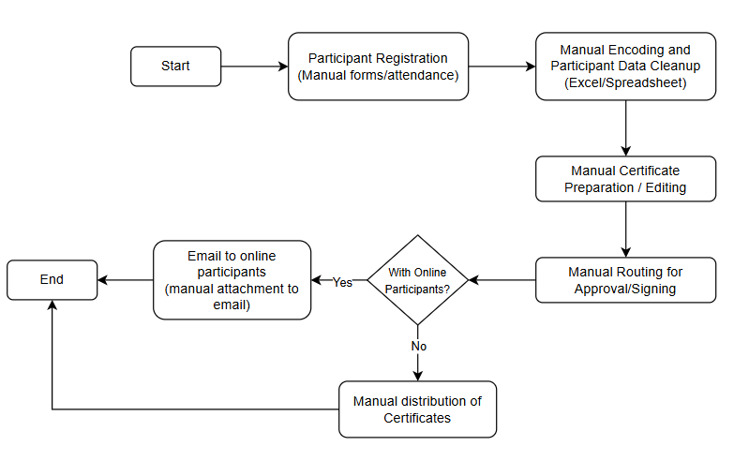
Existing Processflow Diagram

Flowchart 1.1 Existing Processflow Diagram

Existing Process Weak Points Identified

Control Gaps
- No centralized certificate database
- No system-enforced approval checkpoints
- No automated validation or audit trail

Operational Inefficiencies
- Repetitive manual encoding
- Time-consuming certificate generation
- High dependency on human intervention

Risk Areas
- Data entry errors
- Duplicate or inconsistent records
- Risk of unauthorized or unverifiable certificates

The current process indicates that certificate issuance is largely document-driven rather than workflow-driven. Each stage operates as an isolated activity rather than as part of an integrated information system, resulting in process inefficiencies, weak governance controls, and limited scalability. These findings establish the basis for the proposed digital intervention through the CERTIFY system.

PROPOSED WORKFLOW

The proposed system introduces structured workflows, automation, and verification.

Proposed Processflow Diagram

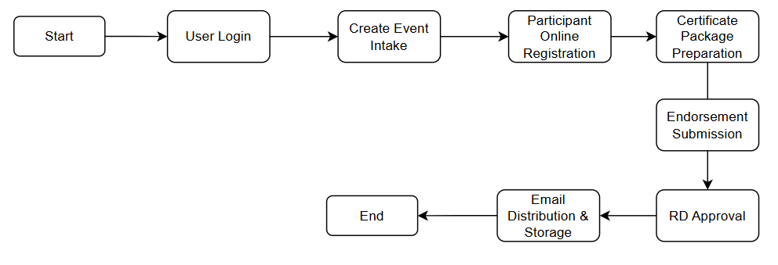

System Architecture Diagram
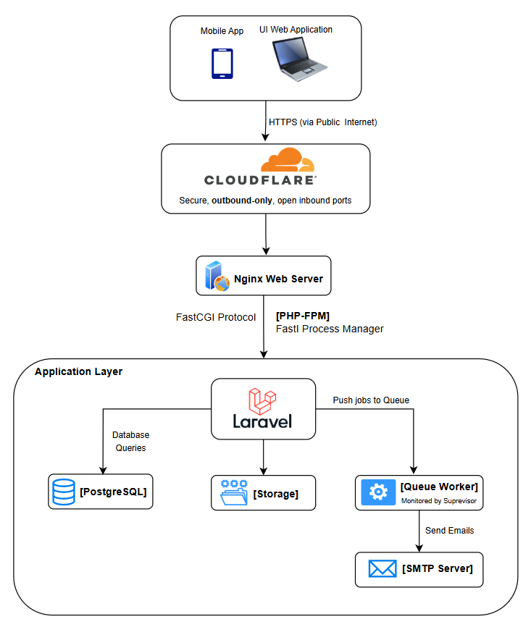

Component Description

Frontend Layer
- Blade Templates + Tailwind CSS
- Lightweight and maintainable

Application Layer
- Laravel Framework
- Handles:
  - Routing
  - Authentication
  - Business Logic

Data Layer
- PostgreSQL
- Structured relational database

Storage Layer
- Secure file storage:
  - Templates
  - Generated certificates

Background Processing
- Queue Worker
- Handles:
  - Email sending
  - Batch operations

Data Flow Diagram
DFD Level 0 - Context Diagram
The CERTIFY system operates as the central processing boundary between external users, internal approving authorities, institutional storage, and public verification users. The main external entities are participants or certificate recipients, organizers and unit supervisors, the Regional Director, public verifiers, the email service, file storage, the PostgreSQL database, and the optional Hedera blockchain bridge.
External Entity: Participant / Certificate Recipient
- Submits profile and attendance information through a participant intake link.
- Receives certificate claim access and certificate notification through email when an address is available.
- Logs in through the recipient guard to view issued certificates tied to the recipient record.
External Entity: Organizer / Unit Supervisor
- Creates participant intake events, reviews collected intake records, exports selected participant data, and submits certificate endorsement packages.
- Uploads participant CSV/XLSX files and certificate template PDFs for controlled processing.
External Entity: Regional Director
- Reviews endorsed certificate packages, approves generation, rejects with required remarks, manages signatory information, and controls user approval and role assignment.
External Entity: Public Verifier
- Scans a QR code or opens a public verification URL containing a UUID public token.
- Receives limited certificate validity information without access to internal administrative functions.
Primary Data Stores
- users: staff accounts, approval status, and role assignment.
- recipients: certificate holder identity, claim status, contact details, profile fields, and authentication credentials.
- participant_intake_events and participant_intakes: public intake links, submitted participant data, event ownership, endorsement status, and recipient linkage.
- certificate_endorsements: staged certificate package metadata, uploaded participant files, uploaded template files, approval state, rejection reason, and generated count.
- certificates: official certificate metadata, public token, recipient linkage, PDF paths, email status, validity status, and blockchain anchor status.
- settings: operational flags and signatory-related configuration where applicable.
- storage/app/private: endorsement templates, participant files, and private certificate source files.
- storage/app/public: publicly served stamped certificates, QR images, and signatory assets where publication is intended.
DFD Level 1 - Main Data Flows
1. Participant Intake Collection: A staff user creates an intake event. The system generates a public tokenized link. Participants submit validated personal, address, organization, demographic, and service-interest data. The system stores the submission, links or creates a recipient record by email, and associates the intake with the event owner.
2. Certificate Package Endorsement: An organizer or unit supervisor uploads a participant file and certificate template with activity metadata. The application validates the payload, normalizes participant names and emails, stores the uploaded files in private storage, and creates a certificate_endorsements record with status endorsed.
3. Approval and Generation: The Regional Director reviews the endorsement. If rejected, the system records the rejection reason and makes the remarks visible in the approvals history. If approved, the system generates certificate records, creates UUID public tokens, stamps or prepares PDFs with QR verification URLs, stores the output, and records generation counts.
4. Email Delivery: For certificates with valid email addresses, the application dispatches a queued email job. The job sends the certificate-ready message, records queued/sent/failed timestamps, and preserves failure messages for administrative review.
5. Public Verification: A verifier opens /verify with a token. The system looks up the certificate by public_token, checks certificate validity, displays limited metadata, and optionally checks the Hedera anchor if the feature is enabled and the certificate is anchored.
6. Recipient Claim and Portal Access: A recipient claims an account through token or lookup/contact verification. After setting a password, certificates matching the recipient email are linked to the recipient_id. Authenticated recipients view only their own certificates through the recipient guard.
7. Analytics and Reporting: Authorized staff query structured certificate and intake data for counts, demographics, programs, topics, locations, and exports. Reporting reads from database records rather than from generated PDF files.
Security Controls in the Data Flow
- Staff operations require session authentication and role middleware. Regional Director-only actions are separated from organizer and unit supervisor actions.
- Recipient operations use a separate guard and separate model to prevent certificate holders from inheriting staff privileges.
- Public verification uses UUID tokens instead of sequential IDs to reduce enumeration risk.
- Uploaded participant files and endorsement templates are stored in private storage until an output is intentionally published.
- Database writes use Laravel validation and Eloquent/query builder APIs, reducing SQL injection exposure when compared with manual SQL concatenation.
- Public routes are throttled where defined, and claim/lookup flows should remain rate-limited to reduce enumeration and brute-force risk.

TECHNOLOGY RESEARCH AND JUSTIFICATION
Technology Stack Evaluation
The selected technology stack is based on maintainability, security, operational fit, local hosting capability, and compatibility with the system workflow. The current implementation uses Laravel 12, PHP 8.3, PostgreSQL 16, Blade/Tailwind for the core application interface, a separate React/TanStack Start frontend under certUI for the SPA layer, database-backed queues, private/public Laravel storage disks, PDF processing libraries, and an optional Hedera bridge for blockchain anchoring.
Laravel 12 and PHP 8.3
Laravel is appropriate for CERTIFY because the system requires authenticated workflows, form validation, role middleware, file uploads, database transactions, mail jobs, and maintainable server-rendered administrative screens. Laravel provides built-in CSRF protection, session authentication, request validation, password hashing, queues, mail integration, storage abstractions, and structured routing. These features directly support the certificate issuance lifecycle without requiring custom security foundations.
PHP 8.3 provides current runtime support, strong framework compatibility, improved performance, and broad hosting availability. It also aligns with the existing Laravel ecosystem and deployment scripts already present in the system.
PostgreSQL 16
PostgreSQL is justified because certificate issuance depends on relational integrity among users, recipients, intakes, endorsements, and certificates. Foreign keys protect recipient and user references, unique constraints protect certificate codes and public tokens, and indexed fields support search, reporting, and verification. PostgreSQL is also suitable for institutional systems because it is open source, mature, ACID-compliant, and reliable for audit-sensitive records.
The application should continue to avoid unnecessary PostgreSQL-only assumptions inside test-covered logic because the automated test environment uses SQLite in memory. PostgreSQL-specific behavior such as ILIKE should be isolated or tested carefully.
Blade, Tailwind CSS, and Laravel Vite
Blade remains a practical choice for the core administrative workflow because many operations are form-heavy, session-based, and tightly integrated with Laravel validation and authorization. Tailwind CSS supports consistent responsive screens without maintaining a large custom CSS framework. Laravel Vite provides asset compilation for production and local development.
React 19 and TanStack Start in certUI
The certUI application provides a more interactive frontend layer for dashboard-style screens and modern component-driven interfaces. React and TanStack Router are appropriate for rich client-side navigation, reusable data tables, interactive forms, and future API-driven workflows. However, authorization must remain enforced by Laravel middleware and server-side policies because client-side role state can only improve user experience, not security.
Database Queue Driver
The database queue driver is appropriate for this deployment because it avoids introducing Redis or another external service while still moving slow operations, such as certificate email delivery and blockchain anchoring, outside the request-response cycle. This improves perceived performance and makes retry/failure tracking manageable. A dedicated queue worker is required in development, Docker, and production.
PDF and QR Processing
The system uses setasign/fpdi-fpdf for PDF handling and simplesoftwareio/simple-qrcode for QR generation. This is justified because certificate output must combine human-readable PDF artifacts with machine-readable verification URLs. Ghostscript and image normalization support compatibility with uploaded templates and generated stamped PDFs.
Private and Public Storage Separation
Laravel storage disks support clear separation between private operational files and public verification artifacts. Participant CSV/XLSX files and endorsement templates contain personal or operational data and should remain private. Stamped certificates and QR assets may be public only when intentionally exposed through verification or download workflows. This boundary reduces accidental disclosure risk.
Hedera Consensus Service Integration
Hedera anchoring is an optional trust-enhancement layer. The Laravel app hashes canonical certificate metadata and submits the anchor through a local Node bridge. Keeping the private Hedera operator key inside a localhost-only bridge reduces key exposure in the PHP application. Verification can then compare the database canonical hash with the message stored on the public ledger. The system must still treat the database and PDF as the authoritative operational record; blockchain anchoring strengthens tamper evidence but does not replace database controls.
Docker and Bare-Metal Deployment
Docker deployment improves reproducibility by packaging PHP extensions, Ghostscript, Nginx, queue workers, PostgreSQL, and backup services. Bare-metal scripts provide operational flexibility for server environments where direct systemd and Nginx management is preferred. The production Dockerfile intentionally requires the Vite build manifest before image build, which prevents incomplete frontend assets from being shipped.
Security Justification
The selected stack supports mandatory security controls: CSRF protection for forms, hashed passwords, session isolation, role middleware, request validation, safe database APIs, private file storage, queue isolation, secret handling through environment variables, and public token verification. Remaining risks should be controlled through rate limiting, least-privilege role assignment, secure backups, HTTPS enforcement, file upload validation, queue monitoring, and regular dependency updates.

SOLUTION APPROACH

Conceptually, the system treats certificate issuance as a controlled transaction that starts from validated user identity and ends with a verifiable public artifact. The key logic is that every certificate must be backed by database metadata and a generated PDF. The database record contains participant and training details, while the PDF contains human-readable certificate content and machine-readable QR verification. This dual structure allows both administrative reporting and external authenticity checking.

The system separates certificate package preparation from approval. This is important because organizers and unit supervisors may have operational responsibility for training activities, but the authority to approve certificates with the Regional Director signatory must remain controlled. The certificate_endorsements table functions as a staging area. It stores the proposed metadata payload and uploaded files before final generation. Once approved, the system converts the staged endorsement into actual certificate records and stamped PDFs.

The participant intake workflow functions as a data collection subsystem rather than a direct certificate generator. This design is practical because participant registration and certificate issuance may not always happen at the same time. Organizers can collect participant data, review it, export selected rows, and later use the export as input to certificate generation. This preserves operational flexibility while still improving structure and validation compared with purely manual forms.

The public verification design uses a UUID public_token instead of exposing certificate IDs. This is a sound security and privacy decision because database IDs are predictable, while UUID tokens are difficult to enumerate. The public route can confirm certificate existence and display relevant certificate metadata, while administrative routes remain protected by authentication and role middleware. This supports transparency without granting public access to internal certificate management functions.

Implementation Strategy
The implementation approach is modular and workflow-driven. The system should preserve clear boundaries among participant intake, endorsement staging, Regional Director approval, certificate generation, recipient claiming, public verification, analytics, and background processing. Each module writes structured records to the database and uses file storage only for the binary artifacts that cannot be represented as relational data.
Phase 1 - Core Governance and Identity: Maintain separate authentication models for staff and recipients. Staff accounts must remain subject to approval status and role assignment. Recipient accounts may exist without passwords until claimed. Regional Director privileges should be granted only through the approved role and backward-compatible is_admin handling where legacy records require it.
Phase 2 - Participant Intake and Recipient Profile Consolidation: Intake links should remain event-scoped and tokenized. Submitted data must pass validation before storage. Existing recipients should be linked by email when possible, while new unclaimed recipient records should be created for first-time participants. Intake data may update recipient profile fields, but sensitive account actions such as password setting must remain inside the recipient claim or profile workflow.
Phase 3 - Endorsement Package Processing: Certificate package preparation should remain separate from approval. Uploaded participant files and template PDFs should be stored privately, validated for type and size, and associated with a certificate_endorsements record. The payload should capture all metadata required to generate certificates later so that approval acts on a reproducible package.
Phase 4 - Approval, Generation, and Distribution: Regional Director approval should trigger controlled generation of certificate records and stamped PDF outputs. Rejections should require remarks so submitters receive actionable feedback. Email delivery should stay queued, and every delivery attempt should update status fields for monitoring and retry analysis.
Phase 5 - Verification and Recipient Access: Public verification must expose only limited certificate information and must use public_token values rather than internal IDs. Recipient dashboards must filter certificates by authenticated recipient_id only. Download and preview routes must check certificate validity before serving files.
Phase 6 - Analytics, Auditability, and Operations: Reporting should use database fields instead of parsing PDFs. Operational logs, queued jobs, email statuses, approval timestamps, rejection remarks, and generated counts should be retained to support audit review. Backups must include both PostgreSQL data and application storage because neither is complete without the other.
Edge Cases and Regression Risks
- Duplicate participants may appear across events or with different email spellings. Matching logic should normalize email and names but avoid unsafe automatic merging when identity is uncertain.
- Uploaded CSV/XLSX files may contain invalid encodings, missing headers, duplicate rows, or malformed email addresses. The parser should continue to normalize encodings and report validation errors before generation.
- Certificate templates may be incompatible PDFs. Ghostscript and PDF normalization reduce this risk, but preview should remain available before endorsement or final generation.
- Email delivery can fail due to invalid addresses or SMTP issues. Status fields and queued retries are required so failures do not block certificate creation.
- Public tokens must remain secret enough to prevent enumeration. Sequential IDs must not be exposed in public verification links.
- Role changes can affect access immediately. Server-side middleware must remain the enforcement point even when certUI displays role-based navigation.
- Storage migration between public and private paths can break old certificates if path resolution is not backward compatible. Existing resolver logic should be preserved when changing storage conventions.
Recommended Controls Before Production Expansion
- Add explicit throttling to recipient claim lookup and claim verification routes.
- Keep a documented backup and restore test covering PostgreSQL plus storage/app.
- Add feature tests for endorsement rejection remarks, recipient claim flows, public verification, and role denial cases.
- Keep Hedera bridge bound to localhost or a private network only, and rotate keys if exposure is suspected.
- Review ignored directories and remove accidental copied artifacts that are not required for deployment.

